Portfolio assignment Unlikely destinations: Houston Texas

**Houston, a city for everyone**

Houston Texas is a lovely place in the world you must definitely have to see with your own eyes. Houston offers a unique experience through its rich culture, interesting history, tasty cuisine and so much more. It is also the city with the most diverse population in the United States. This is reflected in different parts of the city, such as Chinatown, a completely different but of course exquisite culture. For lovers of tasty food, Houston is the place to be. Here the diners could range from luxurious starred restaurants to small cozy family restaurants that are passed on from generation to generation. Many popular dishes in Houston include BBQ, seafood, Asian food .... But if I may speak from my own experience, steakhouses are still my all time favorite. The meat is tender and seasoned just right. Next to your delicious steak you can order a Caesar salad, which pairs perfectly! A remarkable finding when you go out and eat at restaurants in Houston is that you are spoken to by your name/surname and not sir or miss. I believe that this makes you feel more comfortable. You immediately feel welcome and at ease!

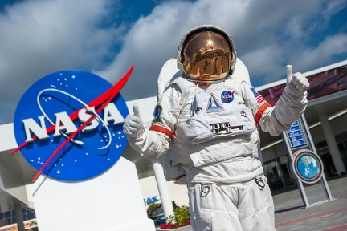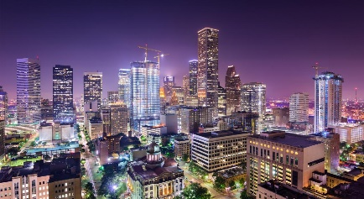Arts also play a big role in Houston, which is why you can visit a huge number of pleasant museums, theatres and art galleries here. You will also see this art reflected on Houston's streets. The walls of buildings are covered with exceptional murals which bring the city to life. This place is known for its creativity. Better yet, it is encouraged to be so. One particular museum you should definitely visit here is the Museum of Natural Science. This museum is a science museum and very interesting if you want to learn more about the history of nature. Now that we are already talking about science, I have another museum that was definitely on my bucket list, namely NASA's Johnson Space Center. This is where astronauts are educated, trained and prepared for later survival in space. Spacecrafts are also built and tested there. Not everything is visible to the public, but the parts we get to admire are, believe me, very impressive. If we take another route, we end up at Houston's opera, theatre and ballet. These beautiful forms of art are definitely worth seeing as well, you will be amazed!

The beautiful and detailed architecture can be seen everywhere in Houston. This creates a stunning skylight that turns red/orange at the mesmerizing sunset and when it should be pitch-black at night the city lights up. This was one of my favorite features of Houston when I lived there and it still is of course!

Believe it or not, but Houston has even more to offer. There is plenty of nature in this big and busy city too, more than 300 parks spread throughout the entire city. Hermann Park is one of the most famous. This is a park with up to 445 acres and it contains a golf course, the Houston Zoo and a 2-mile train track. People in Houston enjoy this green oasis immensely. The locals offer a warm welcome to all visitors, which makes it an incredibly pleasant city to visit. This is their way of life, they are always open to help someone or just have a casual conversation. They make you feel tremendously at home.

And if you want to take home some experiences you will never forget, Houston is where you need to go to. One of them is a gator park, a park full of crocodiles and alligators. When I was in Houston, I myself sat on an alligator, that had a taped mouth, of course. I will never forget this experience! (That is me on the photo at 7 years old sitting on the alligator, from when I lived in Houston.) Another impressive activity is viewing a bull riding game/rodeo. You would be amazed at how aggressive those bulls can be and how brave these people who ride them are.

In short, Houston is a city that offers many fun activities to locals and visitors. This gorgeous city welcomes and accepts all cultures, encourages creativity and has a variety of adventures waiting for you.